CSA0501-DATABASE MANAGEMENT SYSTEMS
LAB EXPERIMENTS DATE: 26/07/2026

EXPERIMENT 11 -- DATABASE WITH AUTO_INCREMENT SEQUENCES

AIM:
To create and use AUTO_INCREMENT sequence in the Flight Reservation System database.

PROCEDURE:
1. Open MySQL Workbench and select the Flight_Reservation database.
2. Create a table with an AUTO_INCREMENT primary key.
3. Insert records without specifying the AUTO_INCREMENT column.
4. Insert a record with a manually specified ID.
5. Remove the AUTO_INCREMENT property from the table.

PROGRAM:
1. Create Passenger_Auto table with AUTO_INCREMENT
CREATE TABLE Passenger_Auto(
Passenger_ID INT AUTO_INCREMENT PRIMARY KEY,
Passenger_Name VARCHAR(50),
Age INT,
Gender CHAR(1),
Email VARCHAR(100)
);
OUTPUT:

2. Populate Passenger_ID using AUTO_INCREMENT
INSERT INTO Passenger_Auto(Passenger_Name,Age,Gender,Email)
VALUES
('Rahul',25,'M','rahul@gmail.com'),
('Priya',22,'F','priya@gmail.com');
SELECT * FROM Passenger_Auto;
OUTPUT:
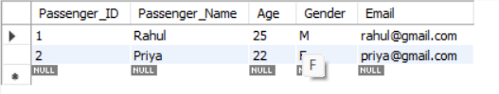

3. Manually populate Passenger_ID
INSERT INTO Passenger_Auto
VALUES
(10,'Akash',27,'M','akash@gmail.com');
SELECT * FROM Passenger_Auto;
OUTPUT:
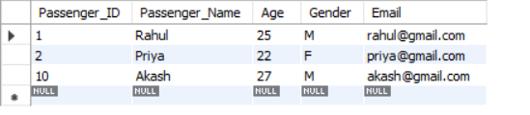

4. Drop AUTO_INCREMENT
ALTER TABLE Passenger_Auto
MODIFY Passenger_ID INT;
DESC Passenger_Auto;
OUTPUT:
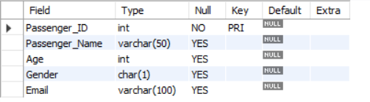

RESULT:
Thus, the AUTO_INCREMENT sequence was successfully created, tested and modified in the Flight Reservation System database.

